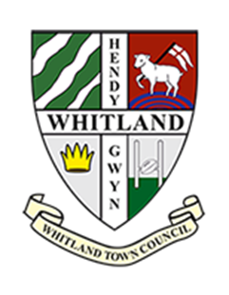
Clerk - Whitland Town Council
Mayor’s Parlour
Whitland Town Hall
Whitland
Carmarthenshire
Email: clerk@whitlandtowncouncil.co.uk

To the Councillors, Whitland Town Council
You are hereby summoned to attend the Extraordinary Meeting of Whitland Town Council to be held on TUESDAY 23rd April 2024, remotely via the medium of Zoom, at 7.00pm. The business to be considered is as set out in the agenda below.

If any member of the public wishes to attend, please contact the Clerk by 1pm on the day of the meeting and you will receive all information to enable you to connect to the meeting.

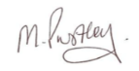

Yours faithfully
Financial Officer/Clerk to the Council (18.04.2024)

All documentation has been Emailed to Councillors prior to the meeting.

The Public Participation session will commence at 7.00pm and will not normally exceed 15 minutes in length. Members of the public are welcome to ask questions or make representations relating to items listed on the agenda only.

Please note that Audio or Video recording of Full Council meetings is not permitted.

All Whitland Town Council meetings are regulated by its Standing Orders.

Agenda
- To accept apologies for absence
- To acknowledge any declarations of interest, as per the Code
- To consider the Whtialnd Town Council accepting the already signed Draft Lease for the area of land within Parc Dr Owen
To either:
- accept the draft Lease in its entirety, but acknowledge that the several suggested amendments, that were brought to the Parc's Solicitor's attention by the Council’s Solicitor, remain unchanged. Thus, ensuring that this matter is brought to fruition following over two years of correspondence, the relationship between the Council, Clerk and Trustees can be built upon positively and the play park can be developed for the Community of Whitland with phase two being installed as soon as possible and funding sought for phase three.

Or

- request the Council’s Solicitor to continue communicating with the Parc's Solicitor, ensuring that a copy of the Deed/s relating to ownership of the Parc is produced, amendments to the Lease, as set out, are considered, and a new Lease drafted, approved by all parties and signed by such. This will further hold up the process, cause more frustration for all parties, and increase the costs to all parties.
All Councillors have received
- a copy of the draft Lease, which has been signed in its original form by the Parc's Trustees, with the Council's Solicitors' annotations on it.

- a copy of the recent Email thread between the Clerk and the Council’s Solicitor.

